# Latent-Based solution Experiments

## Experiment 1:

Use the same autoencoder architecture and loss function of reconstruction based

1. Problem n° 1: the latent space does not seems regular with normal patches:

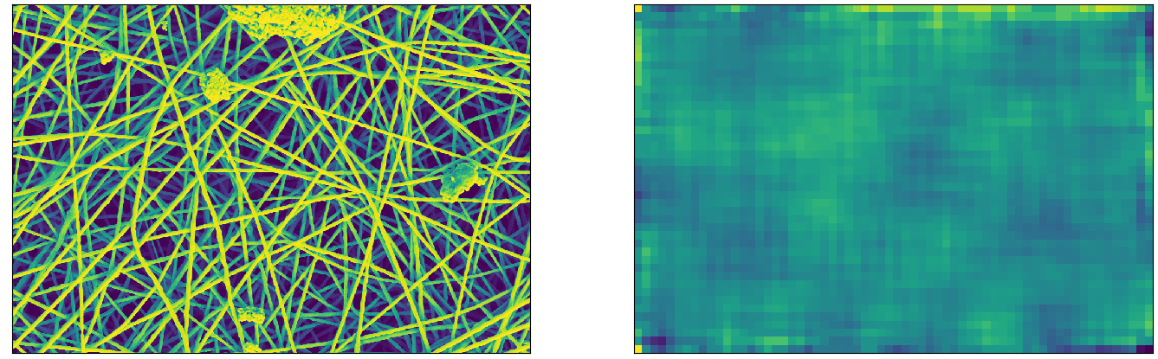

* 1. Solution: Regularize the loss function adding l2 penalty term:

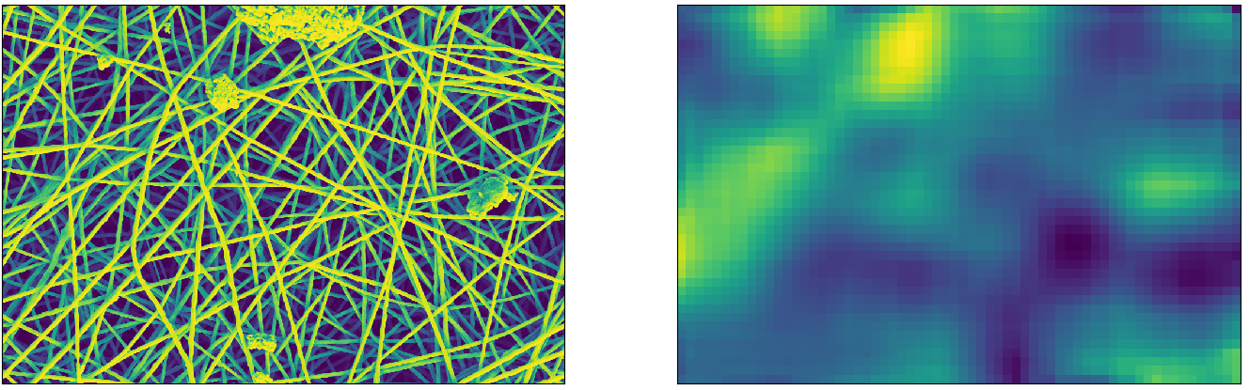

1. Problem n°2: the architecture is built in such a way that the input patch is 128x128 and it is reduced to a 1-dimension array of 512 elements. This fact reduce too much the resolution of the anomaly map, as we can see in the image above.
   1. Solution n°1: Increase spatially the latent dimension, to 8x8xlatent_dim

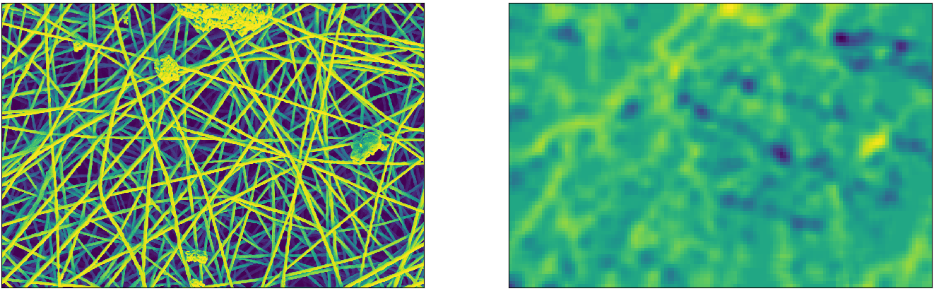

* 1. Solution n°2: Reduce the patch dimension to 32x32 pixel



It seems that the autoencoder is not able to capture features of too small normal patches. In fact we can notice that the anomalies are reconstructed without changes.

